

***School of Mechanical & Manufacturing Engineering (SMME),***

***National University of Science and Technology (NUST)***

**Program**: BE-Aerospace  **Semester**: 2nd

**Session**: Spring 2024 **Course Code**: AE-103

**Engineering drawing Assignment no #1**

**Name:** Sharjeel Asad

**Reg no:** 454248

Figure no 1:

Front view:

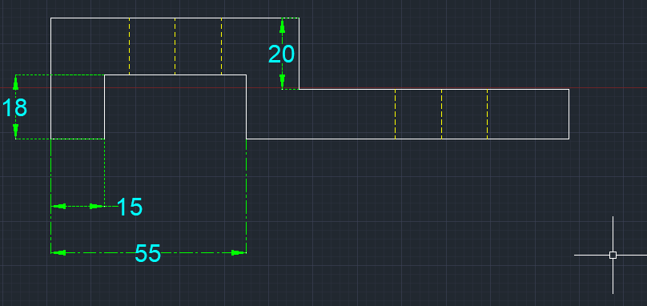

Top view:

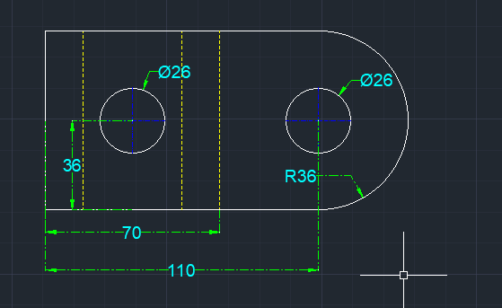

Side view:

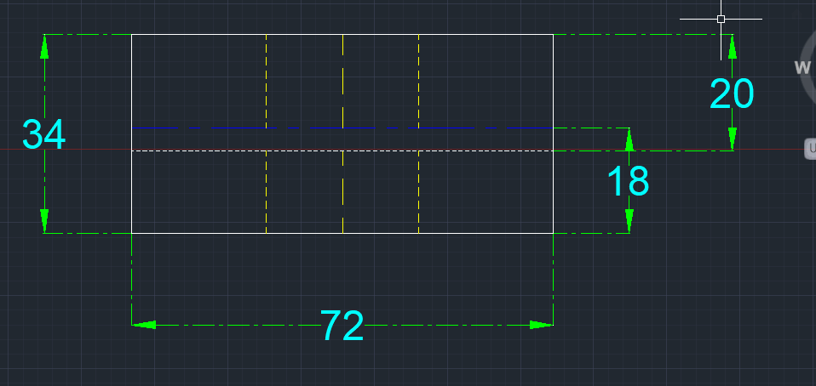

Figure no 2:

front view:

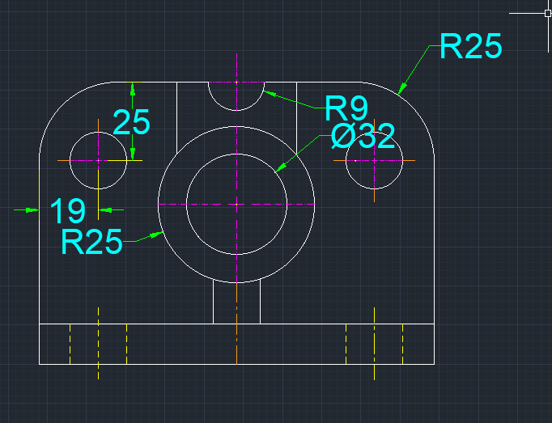

Top view:

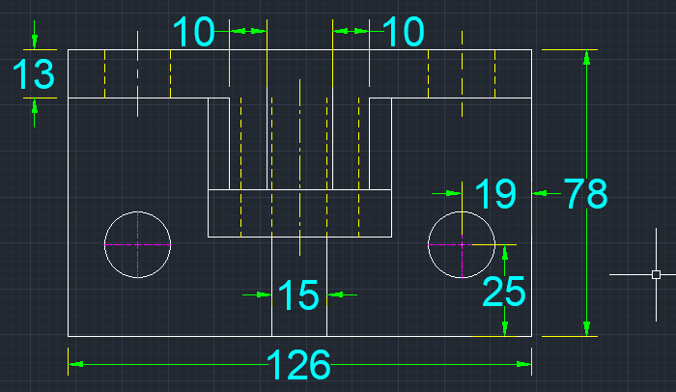

Side view:

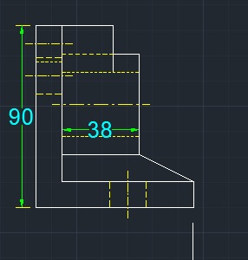

Figure 3:

Front view:

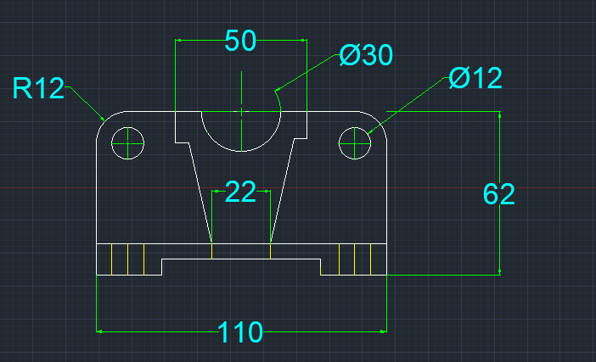

Top view:

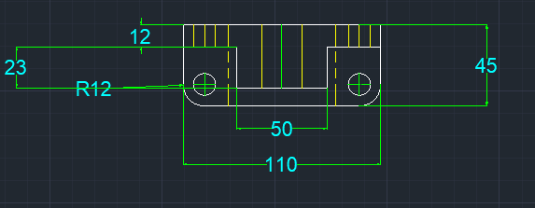

Side view:

